Dublin Institute of Technology

Staff Training & Development – Training of Trainers Short Course



Downstream Processing in Pharma – Biopharma Process Industries

(Two Day Course)

Dr Hassan Ali

Filtration and Drying/Freeze Drying Processes

Date: Monday 14th & Tuesday 15th May 2007
Times: 9.30 a.m. – 5.00 p.m. each day
Venue: School of Chemical & Pharmaceutical Science, DIT Kevin Street, Dublin 8 (Room 114)

For Further Information:
Email: ali.hassan@dit.ie
Tel: (01) 402 2878

FILTRATION PROCESS

The separation of solids from a liquid by means of porous medium or screen which retains the solids and allows the liquid to pass is called filtration. Very small items (such as bacteria) can also be removed (separated) from fluids by filtration process.

Separation process

In general, the pores of the medium are larger than the particles which are to be removed, and the filter works efficiently only after an initial deposit has been trapped in the medium.

In the laboratory, filtration is often carried out using simple filtration apparatus (gravity filtration) or Buchner set (vacuum or suction filtration).
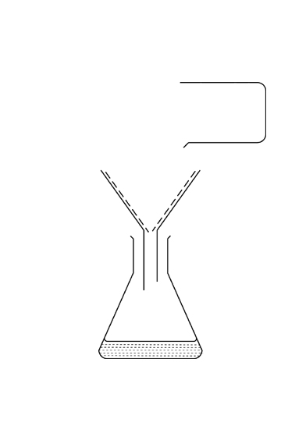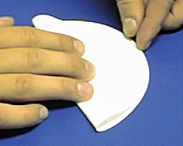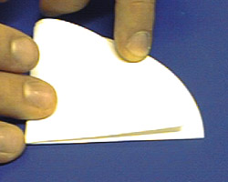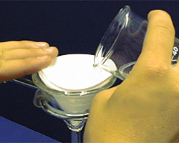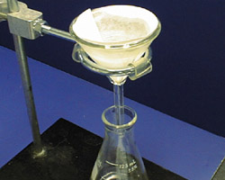

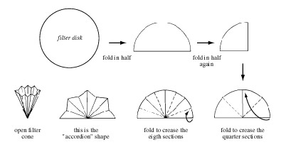

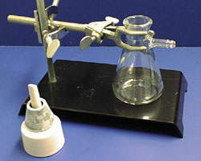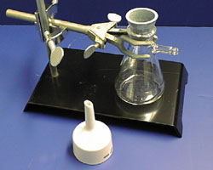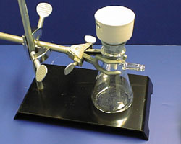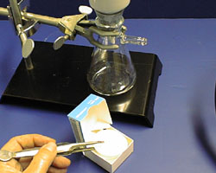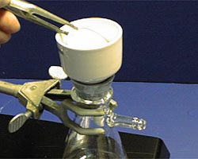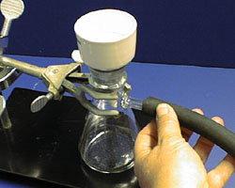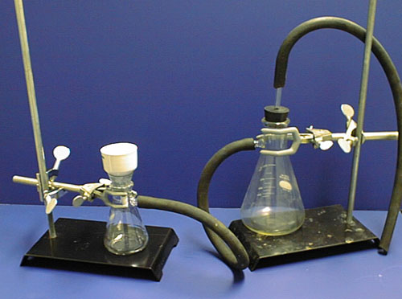

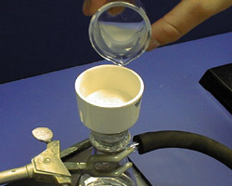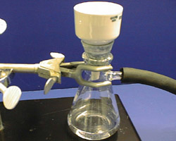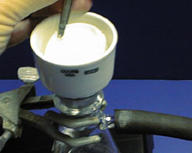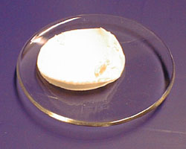

The main factors to be considered when selecting equipment and operating conditions are:

- The properties of fluid, particularly its viscosity, density and corrosive properties.
- The nature of solids – its particle size and shape, size distribution, packing characteristics.
- The concentration of solids in suspension or solution.
- The quantity of material to be handled, and its value.
- Whether the valuable product is the solid, the fluid, or both.
- Whether it is necessary to wash the filtered solids.
- Whether very slight contamination caused by contact of the suspension or filtrate with various components of the equipment is detrimental to the product.
- Whether the feed liquor may be heated (or controlled).
- Whether any form of pre-treatment might be helpful.

Filtration is essentially a mechanical operation and is less demanding in energy than evaporation or drying where the high latent heat of the liquid, which usually water, has to be provided.

In the industrial equivalent, difficulties are encountered in the mechanical handling of much larger quantities suspension and solids. A thicker layer of solids has to form and, in order to achieve a high rate of passage of liquid through the solids, higher pressures are needed, and a far greater area has to be provided. A typical filtration operation is illustrated in the following schematic diagram:

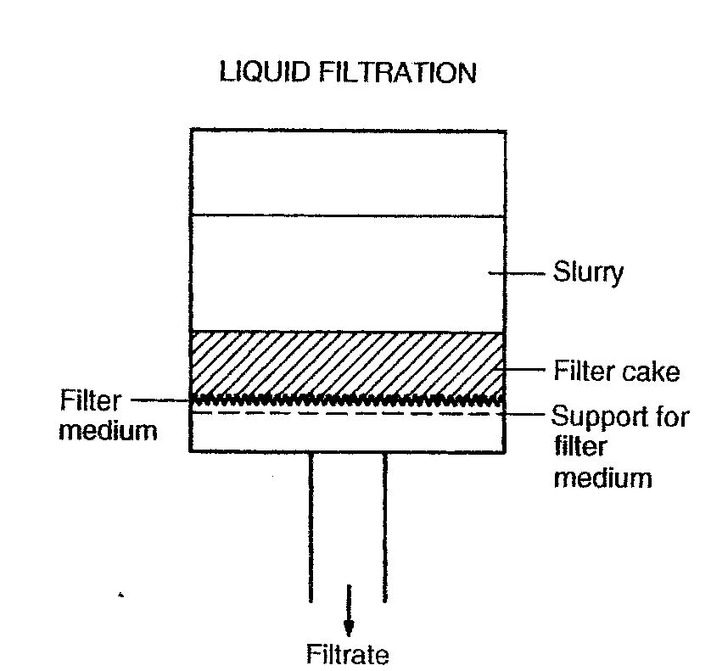

The cake gradually builds up on the medium and the resistance to flow progressively increases. During the initial period of flow, particles are deposited in the surface layers of the cloths to form the true filtering medium. The most important factors on which the rate of filtration then depends will be:

- The drop in pressure from the feed to the far side of the filter medium.
- The area of filtering surface.
- The viscosity of the filtrate.
- The resistance of the filter cake.
- The resistance of the filter medium and initial layers of cake.

The disadvantage of filtration is that the substance being filtered from the fluid will clog the channels through the filter over time:

- Replacing the filter (for example, vacuum cleaner bag).
- Cleaning mechanism for a continuous process.
- For separation where there is a very small size difference, chemical filter may be used. Chemical filters are designed so that the filter can be flushed with chemical that remove the undesirable and allow the filter to be reused.

For a theoretical treatment it is convenient to consider the two resistances to flow separately. Considering the first flow through the cake, this would be expected to be similar to flow through a packed bed, except for the complicating factor that additional liquid passing through deposits solid thus increasing the height of the bed with time. This means either:

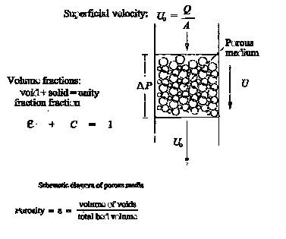

- Flow is kept constant and pressure drop increases with time owing to the increased height.
- Flow decreases with time and pressure drop remains constant or,
- Some combination of the above two cases.

Since small particles form the filter cake it reasonable to assume that Darcy equation holds and hence that the Carman Kozeny will hold so that

U_{c} = k (−ΔP) / ℓ Darcy Eq. flow of fluids through bed

U_{c} = (1/A) (dV/dt) = (1/5) (−ΔP/ μ ℓ S²) {e³/ (1−e)²} Kozeny Eq.

Where;
k = proportionality constant
ΔP = pressure drop across the bed or applied pressure defence
U_{c} = average velocity of flow of the fluid defined as (1/A) (dV/dt), also it is
defined as the superficial velocity of the filtrate
A = total cross sectional area of bed or total cross sectional area of the filter
cake
V = volume of filtrate which has passed in time t
ℓ = cake thickness
S = specific surface of the particle
e = voidage
μ = viscosity of filtrate
dV/dt = volumetric flow rate

Same system units should be applied in these relationships

The above relationship can be written as:

(1/A)(dV/dt) = (−ΔP/ 5 μ ℓ) {e³/ S² (1−e)²}

Filter cakes can be divided into two classes:

- Incompressible cakes and
- Compressible cakes

In the case of an incompressible cake, the resistance to flow is not affected either by the pressure difference across the cake or by rate of deposition of material. On other hand, with a compressible cake, increase of the pressure difference or of the rate flow causes the formation of a dense cake with a higher resistance.

For an incompressible cake the term e³/ 5 (1 − e)² S² is constant. One can define a specific resistance (r) of the cake as:

r = 5 (1 − e)² S² / e³ (m⁻²)

r is a property of the particle forming the cake and should be constant for a given material. It depends on e & s on rate of deposition, nature of particles, and on the forces between the particles.

Hence (1/A)(dV/dt) = (−ΔP/ r μ ℓ) ‘the basic filtration design equation’

If v is the volume of the cake deposited by unit volume of filtrate then:

v = ℓA/V OR ℓ = vV/A {(volume of cake/volume of filtrate) (volume of filtrate)}/cross sectional area

Substituting for ℓ in the basic filtration equation:

(1/A)(dV/dt) = (−ΔP/ r μ) ( A/vV) OR (dV/dt) = A²(−ΔP)/ r μ vV)

The later relationship may be regarded as the basic relation between (−ΔP), V and t.

Two important types of operation are considered:

- The pressure difference is maintained constant and
- The filtration rate of filtration is maintained constant.

Filtration @ constant pressure difference:

(dV/dt) = A²(−ΔP)/ r μ vV) Rearrange gives: VdV = {A²(−ΔP)/ r μ vV)}dt

When ΔP is constant, the only variables in the previous equation are V and t. when t = 0, V = 0. Integrate gives:

V²/2 = {A²(−ΔP)/ r μ v}t OR t/V = (r μ vV/2A²(−ΔP)

Thus; for filtration at constant pressure there is a linear relationship between V² and t or t/V and V.

When t₁ ≠ 0 ⇒ V₁ ≠ 0 then:

V t
∫ VdV = ∫ {A²(−ΔP)/ r μ v}dt
V₁ t₁

Integrate gives:

(t − t₁) / (V − V₁) = {(r μ v/2A²(−ΔP)} (V − V₁) + (r μ vV₁/A²(−ΔP)
……………….. ………………
Slop e intercept

(t − t₁) / (V − V₁) is then plotted against (V − V₁) a linear relationship is obtained.

(t − t₁) / (V − V₁) = {(r μ v/2A²(−ΔP)} (V − V₁) + (r μ vV₁/A²(−ΔP)+ (r μ L/A(−ΔP)
……………….. …………………………………
Slop e intercept

Filtration @ constant rate filtration:

In this case dV/dt = V/t = constant

So that V/t = A²(−ΔP)/ r μ vV

Or V/t = {r μ v / A²(−ΔP)} V

Example:
A rotary disc filter is to be used to filter solid product. The filter rotates at ¼ revolution per minute with 25% of its surface submerged and an internal pressure of 34.5 kNm⁻² absolute is maintained.
Some of the slurry was tested on a plate and frame press in the laboratory at a constant pressure differential of 70 kNm⁻² and yielded the following results

Time ‘min.’ Filtrate volume / m² surface

7 3.048
20 6.096
30 7.620
40 9.144

Determine the area required for the disc filter if 100 tonne/day of solids are to be filtered from the slurry containing 8%_{w/w} of solid.
Atmospheric pressure = 101.3 kNm⁻²
Density of liquid = 1000 kg m⁻³

Solution:
From data given find the value of tA/V vs each measurement
2.297, 3.281,3.937, 4.374

(t − t₁) / (V − V₁) = {(r μ v/2A²(−ΔP)} (V − V₁) + (r μ vV₁/A²(−ΔP)+ (r μ L/A(−ΔP)

OR

(tA) / (V) = {(r μ v/2) (1/ΔP) (V/A) + (r μ L/ (−ΔP)

Plot gives slope = 0.37 min/m² = r μ v/2ΔP OR r μ v = 0.37 2 70
= 51.9 kN min / m⁴

Intercept = 1.1 = (r μ L/ (−ΔP) OR r μ L= 1.1 70 = 77 min.kN .m⁻³

Production of solid = 100 1000 / 24 60
= 69.4 kg min⁻¹

Weight of filtrate = 69.4 0.92/0.08
= 798.6 ≈ 800 kg min⁻¹

Density = mass/volume volume of filtrate = 0.8 m³min⁻¹

ΔP = 101.3 – 34.5 = 66.8 kNm⁻²

Area of filter = A, submerged area = 0.25A time (t) = 1 min

Substitute into this equation [(tA) / (V) = {(r μ v/2) (1/ΔP) (V/A) + (r μ L/ (−ΔP)] gives A= 4.56 m²

DRYIND & FREEZE DRYING PROCESS

Introduction

- The drying of materials-whether solids, solution (liquid) or slurries- is the final operation in a manufacturing process, carried out prior to packaging or dispatch.

- Drying refers to the final removal of water (or other solvent). The drying operation often follows evaporation, filtration or crystallisation. Generally it is a separation process.

- All drying processes involve the removal of water (or other organic liquid) or moisture by vaporisation, and thus require the addition of heat.

⇒ Drying is a separation unit operation process which involves the simultaneous heat and mass transfer.

For example drying of solid involves the simultaneous transfer of heat to evaporate the liquid and transfer of moisture as liquid or vapour within the solid and vapour from the surface, usually into a hot carrier gas.

HEAT TRANSFER - heat of vaporisation, (hot gas or surface).

MASS TRANSFER – depends on concentration gradient and
TYPE OF SOLIDS:

- Porous or non-porous
- Hygroscopic or non-hygroscopic

The heat is usually transferred to the surface of the material to be dried. It may be:
- By convection from hot gas (air)
- By conduction through contact with heated surface
- By radiation, or
- By a combination of these

Dryers are in operation in most manufacturing industries including chemical, food and pharmaceutical.
Products that are dried range from organic pigments to proteins, as well minerals to dairy products.

⇒
- Because of the spectrum of duties required, there is a great variety of dryers available.

- The correct choice depends on the properties of the feed material and the desired characteristics of the final product.

- Dryers are either suitable for BATCH or CONTINUOUS operation.

Drying is carried out for one or more of the following reasons:

- To reduce the cost of transport

- To make a material more suitable for handling, for example, soap powder, dyestuff, fertiliser

- To provide definite properties, such as maintaining the free –flowing of salt

- To remove moisture which may otherwise lead to corrosion, and to improve storage life

With a crystalline product it is essential that crystal are not damage during drying, and, in the case of pharmaceutical products, care must be taken to avoid contamination.

FEED DEFINITIONS

⇒ Feed: solids, paste, solution, slurry

Solution: solids fully dissolved in liquid

Slurry: suspended or dispersed

Thixotropic: thins with shear

Dilatant: thickens with shear

Cohesive paste: just plain sticky

Friable cake: dry to touch, breaks up

Granules: coarse powder

DRIED PRODUCT CHARECTERISTICS

Fine: typically pigment powders, fillers, talcum powder

Free flowing: usually over 50 microns, press filling applications

Dustless: dyes, bulk handling

Granular: coarser and less free flowing

Wettable: for easy mixing into water

Agglomerated: easiest mixing and dissolving- infant formula,

Coated: time release, lecithinated, flavoured

Lump: cattle feed

⇒ Heat sensitive? Size/size range?

MODE OF OPERATION:

- Atmospheric (cheap) or

- Vacuum (fast, safer, good for heat sensitive feed, good for solvent recover)

BATCH OR CONTINUOUS; DEPENDS ON THE SCALE OF THE PROCESS

DIRECT OR INDIRECT CONTACT; does heated surface or air do the drying?

For selection guide PERRY’S CHEMICAL ENGINEERS HANDBOOK is very useful.

DRYING OF SOLIDS:

- It is an operation of widespread importance in chemical, food and pharmaceutical industries and in the processing of natural products.

- It involves vaporisation of the liquid contained by the solid, followed by the removal of the vapour in a stream of air or other carrier gas.

- For this purpose the liquid, normally water, in the solid must travel from the interior out to the surface and this may involve a number of mechanisms.

- The basic requirement is the supply of the heat of vaporisation of water and a sufficient flow of air for the removal of the vapour.

- The energy requirement is large because of the latent heat of vaporisation.

    - Thus, there is a wide variety of dryer designs, to cater for the specific solid, drying conditions and finished product specification.
    - Economy of energy usage is important with all design.

DRYING OF SOLUTIONS & SLURRIES

The drying process for slurries or solutions dried as droplet is similar to that for wet bulb solids.

    - Characteristically the rate of drying tends to be constant whilst the surface remains saturated, followed by a period, or periods, in which the rate falls off with time.

    - This fall of drying rate is due to that the moisture must travel to the surface, generally by diffusion through pores in the formed crust

Spray drying involves the transformation of a feed of solution, or slurry, into particulated dried-product by the removal of moisture in a single operation. In practice feed can be a solution, suspension or paste depending on the upstream. The dried product is recovered in a series of separation stages. The gas flow may be:
      - co-current flow in which feed and air pass through the dryer in the same direction ( this arrangement is widely used for products where rapid solid formation is required and the product is heat sensitive).
      - alternatively, the sprays can be contacted with air in counter-current flow (feed and ail through the dryer in opposite direction) or mixed flow.
      - drop sizes are generally in range of 10 to 1000 μm.

Humidity is water content of gas, (H) = kg H₂O/kg dry gas

Relative Humidity (H_{R}) = partial pressure of water vapour/svp @same T

i.e. H_{R}=100% for saturated gas, 0% for totally dry.

€(THERMAL means) > €(MECHANICAL means)

e.g. Tumble Clothes dryer vs. Spin dryer

DRYING MECHANISMS

Rates of drying:

- In dying, it is necessary to remove free moisture from the surface and also moisture from the interior of the material.

- The transfer of liquid inside the solid may occur by several mechanisms, such as diffusion in homogeneous solids, capillary flow in granular and porous solids, flow by shrinkage and pressure gradients, and flow caused by a sequence of vaporisation and condensation.

‘Bottom graph most useful for analyses

Moisture Content (kg/kg) Drying Rate (kg/kg. m².hr)

…………………………….
X*

Time Time

Drying Rate (kg/kg. m².hr)

Passage of time

Moisture Content (kg/kg)

Drying rates curve:

The form of the drying rate curve varies with the STRUCTURE & TYPE of material, and two typical curves are illustrated in the following figures:

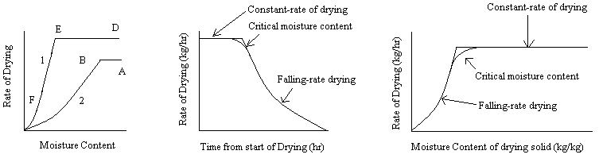

In curve 2 there are 2 well defined zones:

- AB, where rate of drying is constant; and

- BC, where there is a steady fall in the rate of drying as the moisture content is reduced.

The drying of soap gives rise to a curve of type 2.l

Curve 1 shows 3 stages: DE, EF, &F0:
- DE constant rate period.

- EF & F0 are the falling rate periods. 1st FRP & 2nd FRP (final stage).

Drying of sand is a typical example to show such behaviour.

Constant Rate Period:
air flow

water
wet solid

Falling rate periods:
air flow

wet solid

air flow

dry solid
wet solid

Selection of Dryers

- Temperature and pressure in the dryer

- The method of heating

- The means by which moist material is transported through the dryer

- The way in which the moist material is supported

- The method by which the air is circulated

- The heating medium, and

- The nature of the wet feed and the way it is introduced into the dryer.

Drying Apparatus – Solids and Pastes

- Tray (or Cabinet) Dryer

Convenient and economical for small quantities, different products, or for test and development work. Material to be dried, spread on trays and directly loaded into the dryer, usually holding 10 or 20 trays.

For larger quantities the trays are first loaded onto trolleys holding 40 or 60 trays which are in turn positioned in the drying oven. Standard capacities are 1, 2, 4 and 8 trucks.

Drying is by convection with recirculation of hot air across the tray, using steam, electric or gas as the heat source.

- Simple operation, small capacity batch, handles many types of feed.

- Trays either solid or screen-bottomed.

- Drying rates varies between entry and exit

- Loading/unloading is by hand, ⇒ expensive

- Adaptable to freeze-drying (coffee, drugs, vitamins, etc.)

- Tray Dryers with vacuum

This type of dehydrator uses a vacuum to maintain the lowest possible vapour pressure in the space around the product.

The reduction in pressure also reduces the temperature at which product moisture evaporates, resulting in improvements in product quality.

- Screen - Conveyer

Suitable for coarse granular/flaky fibrous solids, performable pastes.

Unsuitable for solutions, slurries, very fine materials.

Continuous, gentle action.

Each section of apparatus can have different conditions.

- Tunnel Dryers

In this system the heated drying air is at one end of the tunnel and moves through trays of products being carried on trucks.

- The product trucks are moved through the tunnel.
- The product can be moved in the same direction as the air flow to provide co-current dehydration or in a counter-current manner.
- With co-current systems, high-moisture products is exposed to high temperature air and evaporation assists in maintaining lower product temperature.
- At locations near the tunnel exit, the lower-moisture product is exposed to lower temperature air.
- In co-current system, lower moisture product is exposed to high-temperature air and a smaller temperature gradient near the product entrance to the tunnel.
- The product trucks are moved through the tunnel.
- The product can be moved in the same direction as the air flow to provide co-current dehydration or in a counter-current manner.
- With co-current systems, high-moisture products is exposed to high temperature air and evaporation assists in maintaining lower product temperature.
- At locations near the tunnel exit, the lower-moisture product is exposed to lower temperature air.
- In co-current system, lower moisture product is exposed to high-temperature air and a smaller temperature gradient near the product entrance to the tunnel.

- Rotary

Finer granular feeds than screen conveyer, e.g. salt, sugar.
Solids showered through hot ail.

-In this dryer a product is transported along a slightly inclined cylindrical shell that rotes slowly.
-The moist product and the hot drying air are introduced at one end of the shell and the dried products and the moist air exit at the other end.
-the inside of the shell is fitted with a set of flights that repeatedly lift the products a certain distance a long the periphery of the rotating shell before they fall back to the bottom of the shell

⇒ more exposed surface area
⇒ shorter drying time

Rotary dryers could be operated under atmospheric or vacuum conditions.

- Rotary Vacuum Dryer
Operating Principle
Wet feed is charged as a batch and is subjected to indirect heating while undergoing agitation due to the action of paddle mixing, The operation is normally carried out in vacuum. Recovery of solvent is possible by condensing the vapours generated during the drying operation.
Special Features of Rotary Vacuum Dryer
- Granular / pasty wet materials can be handled.
- Low temperature operation is possible.
- Solvent recovery can be carried out
- System is batch
- High energy efficient
- Mode of heating is indirect
- Conduction drying
- Closed operation
Typical Applications: pharmaceuticals, pasty materials, dyestuffs, organic chemicals, insecticides, pesticides, solvent recovery

- Screw Conveyer

Handles finer & stickier feeds than rotary
Continuous process& indirect heating (horizontal screw conveyer in jacket shell)

- Screen - Conveyer (Belt conveyer dryer)

Suitable for coarse granular/flaky fibrous solids, performable pastes.

Unsuitable for solutions, slurries, very fine materials.

Continuous, gentle action.

Each section of apparatus can have different conditions.

- Rotary

Finer granular feeds than screen conveyer, e.g. salt, sugar.
Solids showered through hot ail.

-In this dryer a product is transported along a slightly inclined cylindrical shell that rotes slowly.

-The moist product and the hot drying air are introduced at one end of the shell and the dried products and the moist air exit at the other end.

-the inside of the shell is fitted with a set of flights that repeatedly lift the products a certain distance a long the periphery of the rotating shell before they fall back to the bottom of the shell

⇒ more exposed surface area
⇒ shorter drying time

Rotary dryers could be operated under atmospheric or vacuum conditions.

Mode of heat could be direct or indirect. Direct heating, where the hot gasses or air pass through the material in there dryer. Indirect heating, where the material in an inner shell, heated externally by hot gases.

- Fluid Bed (Fluidised Bed) Dryer

In this system, the product pieces are suspended in the heated air throughout the time required for drying.

The movement of the product through the system is enhanced by the change in mass of individual particles as moisture is evaporated.

Drying time ~ 30 minutes

Rapid mixing & heat transfer

Batch operation possible

Many large scale uses include the drying of fertilisers, plastic materials.

Small fluidised bed dryers are finding use in, for example, the drying of tablets and granulations in the pharmaceutical industries.

Drying Apparatus – Solutions & Slurries

- Spray Dryer

The drying of liquid product is often accomplished in a spray dryer.

e.g. detergent, blood plasma, enzymes, dyes, alumina, coffee, milk, foodstuff.

Moisture removal from a liquid occurs after the liquid is atomized or sprayed into heated air with a drying chamber. The slurry or solution dispersed as mist droplet in hot gas.
Droplets must not touch wall ⇒ large chamber needed
Very short drying times (2 to 20 sec.)
Much heat lost through exit gas
Products hollow & very porous
Uniformity of droplets size is critical (too big ⇒ under dried; too small ⇒ over dried). Therefore atomizer/spray nozzle of correct design is needed.

- Drum

Liquid evaporated from outside of one (or more) heated metal roll(s)
Unsuitable for abrasive solids (surface is scratched)
Contact time with hot metal=6 to 15 sec.

⇒ If a solution or slurry is run on to a rotating heated drum (steam may be used as a heat source), evaporation takes place and solids may be obtained in a dry form. This is the basic principle used in all drum dryers. Many feed configurations some forms are illustrated bellow:

Freeze-drying (Lyophilisation)
A method of drying food or pharmaceutical with out destroying their physical structure; material is frozen and then warmed in a vacuum so that the ice sublimes.
Freeze drying is a low pressure, low temperature process. It dries materials by exposure to very cold air.

There are many definitions of freeze-drying, some of which incompletely define the process. The term ‘lyophilisation’ (‘lyophilization’ in the US) is also used to describe the same process, although, technically speaking, to make a material into a ‘lyophile’ (from Greek ‘lyo’ [solvent] and ‘philos’ [seeking], which is one of the principal attributes of a successfully freeze-dried product) could theoretically be achieved using many different methods.
Freeze-drying is a unit operation that is widely used in the production of a wide range of products, including diagnostics, vaccines, pharmaceuticals, biotech products, foods and beverages.
Operationally, we could define the freeze-drying process as a controllable method of dehydrating labile materials, often of biological origin, by desiccation under vacuum. This may be to achieve better stability compared to the initial formulation, or simply because the freeze-dried form is preferred by the end user, or a combination of these.
As a stepwise process, freeze-drying might typically involve:
- Cooling of the initial formulation (which may be a solution, suspension, emulsion, slurry or a more complex mixture or structure)
- Conversion of freezable solvent (usually water) into a solid
- Crystallisation of crystallisable solutes, with the persistence of an amorphous matrix composed of non-crystallising solutes and non-freezable solvent
- Sublimation of the solid solvent (usually ice) under vacuum
- “Evaporation” of unfrozen solvent from the amorphous matrix
- Desorption of chemi-sorbed solvent resident in the apparently dried product (often referred to as a ‘cake’ or ‘plug’)
- Sealing of the product in its container if appropriate, either under vacuum or ‘backfilled’ with a non-reactive gas such as nitrogen or argon
Process description:

The material is held on shelves or belt in a chamber that is under high vacuum. In most cases, the material (e.g. food) is frozen before being loaded into the dryer. Heat is transferred to the food by conduction or radiation and the vapour is removed by vacuum pump and then condensed.

- This process is highly suitable for heat sensitive feed
- Material is FROZEN to 240 to 260K) quickly (keeps ice crystal small so that cell are not ruptured)
- Gently heated under high vacuum (10 to 40 Pa)
- Moisture sublimation occurs (i.e. solid vapour)
- Heat provided uniformly to feed must be: enough to sublime moisture, but not to melt material
- Wide usage for food& penicillin has reduced cost
- Batch process on truck/tray basis most common
- Continuous process in development??????

Freeze-drying may be carried out in a number of formats. The most common formats are vials and ampoules - usually when freeze-drying is the final stage of the production process – or trays (known as ‘bulk drying’) – usually where freeze-drying is used as an intermediate step in the production process (e.g. to concentrate an active ingredient prior to further processing such as tabletting).

OTHER DRYERS:

-TOWER DRYERS
-INFRA RED HEATINGS
-ULTRASONI

