C Mc Donnell Sept 2008

INFORMATION RETRIEVAL -

LITERATURE (and WEB) SEARCHING

1. Planning and organising your literature search
2. DIT Library Resources
- Other Libraries
4. Other Information Sources

“Two weeks in the laboratory will save you three hours in the library”

Prof S. Danishefsky, quoted in “Library Handbook for Organic Chemists” by A. Poss, Chemical Publishing Co., 2000.

CODE OF CONDUCT

Books and journals are reference materials and should be available to everyone.
DO NOT REMOVE OR DAMAGE BOOKS OR JOURNALS PLEASE.
DO NOT DAMAGE COMPUTERS AND PLEASE REPORT ANY FAULTS.

General Information
Sources of information may be primary, secondary or tertiary;

Primary | Secondary | Tertiary
Journals | Reviews | Books
Technical reports | Monographs
Patents
Conference papers
Dissertations/Theses

A very useful source of relevant information - the guides produced by the Kevin St. Library.

Internet chemist tutorial;
http://www.vts.rdn.ac.uk/tutorial/chemistry

- Planning and Organising Your Literature or Web Search

What information do you require?

-Define your topic if necessary (dictionary / encyclopedia)

-Identify the purpose of your literature search. Decide which key words or chemical names / molecular formulae / technologies you need to look for.

-Prepare your search statement for book indexes, catalogues and databases. Think of synonyms, American spelling etc.

-Try to keep your search topics at a workable level - not too narrow or too wide (Use AND, OR, NOT as required. Use truncation if helpful (e.g. pharma* covers pharmaceutical, pharmacology, pharmaceutics etc.)

-“Snowballing” – once you have one relevant reference, you can use this as a basis for future searches –
- the references cited,
- the keywords or identifiers were used to classify this reference,
- the other articles that have cited the reference (if it is a journal article).

-Categorise and prioritise your search topics with regard to the time, cost and travel you’re willing to invest.

-Finally, evaluate the references obtained and consider if they are up to date, relevant, at a suitable level, written by an expert in the field and easily obtained.

What details will you need for your bibliography?
A reference requires book / journal title, author(s), page numbers and year published. The volume number is required for a journal. The publisher (name and city) and edition is required for books. Consult any Journal of the Chemical Society or The Journal of the American Chemical Society for the standard reference format used.

“The ACS Style Guide: A Manual for Authors and Editors”, 2nd Edition, ACS, (808.066)

(Also, Harvard Reference System – Humanities and Social Sciences).

When carrying out your search, use a notebook – preferably hardback – to note down references you’re looking for and their subject matter. Web site addresses consulted (and date consulted) can also be recorded there.

BEWARE – Check that photocopies are identified as to their source. Book titles are rarely printed as a header on every page. Photocopy cover page.

- Write down the search details you used to get to useful information.

- DIT Library Resources

DIT catalogue is online (Online Public Access Catalogue - OPAC). http://www.dit.ie/library/
Can access remotely and can renew books etc. online
Check if is companion website for texts.

BOOKS are filed under Dewey system. Individual call number for each book. Books with similar call numbers grouped together e.g. 660.2 is Industrial Chemistry.
Reference books provide a lot of information – e.g. Encyclopedia of Analytical Chemistry, Encyclopedia of Pharmaceutical Technology, Dictionary of Organic Compounds, Comprehensive Organic Transformations by R. Larock.
(Also videos and CD roms)
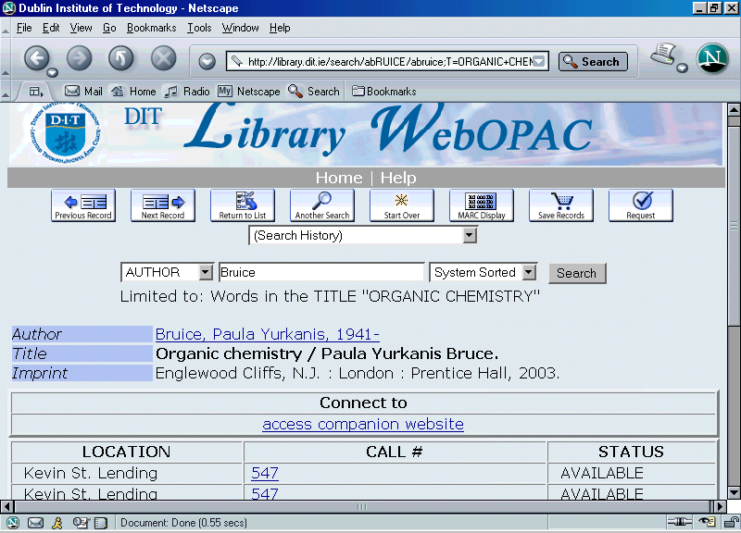

JOURNALS
Hard Copys- e.g. Journal of Validation Technology, Chemistry World (Chemistry in Britain), Organic Process Research and Development, Chemical Society Reviews, Chemical and Engineering News.
Current issues shelved on display (alphabetical order). Recent issues (last 6 months) on shelf behind display.
Older issues boxed or shelved at end of library.
Scientific American, New Scientist, Nature and Science journals are held behind the desk. These journals are useful for material for your introduction and information on general applications of your report/project/presentation. (also Irish Times archive - Information Resources /Databases/Irish Times, and The Economist, Business and Finance)

Project and thesis report titles list on top of card catalogue. Projects can be requested at library desk.
Patent reprints can be requested at the library desk but will take some time to obtain.
Also see, United States Patent Office website,
http://www.uspto.gov/
European patents, espacenet.com website

Inter-library loans can be submitted at the desk and also take some time to obtain (supervisor/course coordinator’s signature needed).

Electronic Databases
Go to DIT Library OPAC http://www.dit.ie/library/
Select Information Resources.
Select Databases.
Examples
-Web of Science
-Applied Science and Technology Abstracts
-Science Citation Index
-CHIP – Chemical Hazard Information
-Irish Times
-Dissertation Databases
-Index to Theses (by subject)

Electronic Journals
Select Information Resources.
Select Electronic Journals.
- Journals available include;

Chemical Society Reviews, Journal of Biotechnology, Journal of Chemical Research, Journal of Materials

Chemistry, Journal of the Chemical Society, Physical

Chemistry Chemical Physics, Polymer, Total Quality

Management.

Table of Contents search is very useful also

- Searching the Crossfire Database (Beilstein / Gmelin)
This database can be accessed using all computers in room 346. It provides comprehensive literature access and has a structure search facility compatible with Isis Draw.
There is a help menu available within the database and a short tutorial at the following link;

http://www.library.qmul.ac.uk/sci/beilstei.htm#search

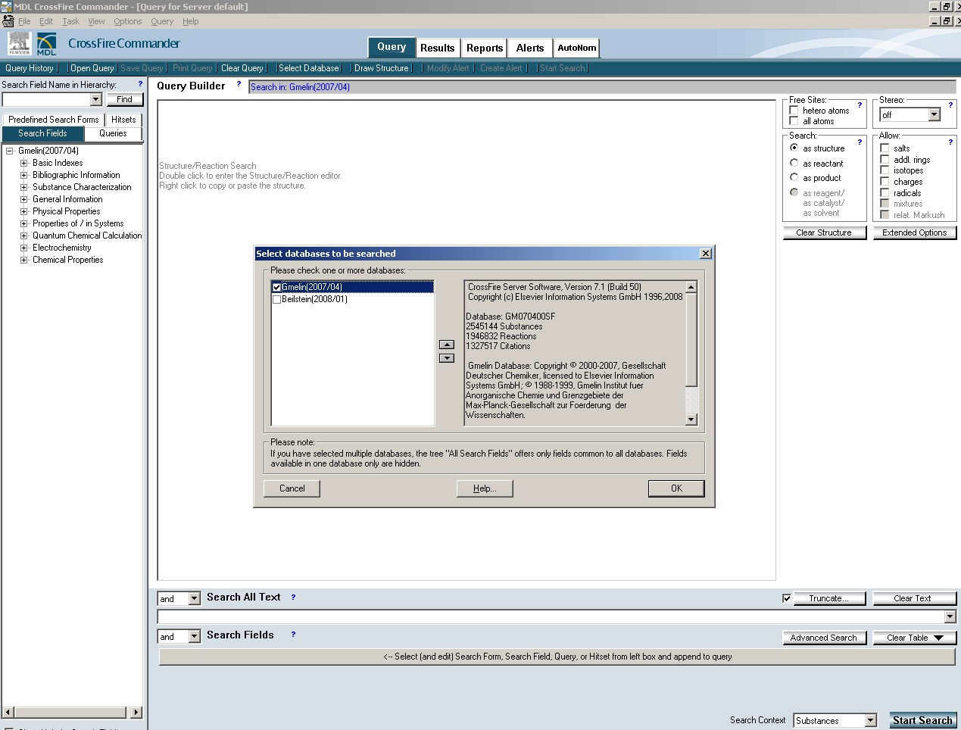

- Other Libraries

You can search the on-line catalogues of other libraries using the DIT library website.
Select Information Resources.
Select Search Other Catalogues.

TCD Library
http://www2.tcd.ie/Library/
Personal library pass valid for 1 week (Mon-Sat) available with letter of introduction from DIT library.
Journals may be in the Chemistry Dept. library (restricted hours), the Hamilton library or elsewhere.
Refer to information sheet available at desk in Kevin St.

UCD Library
http://www.ucd.ie/library/
Letter of introduction needed for access – valid for 1 day only. No external readers for April-June.
Most books and journals in Belfield Main Library levels 3 & 4. Some journal holdings in Chemistry Dept library.

ALCID Card
http://www.dit.ie/library/librarya-z/alcid/

- Other Information Sources
Some commonly used sources are available in a filing cabinet in Lab 314 (Prep Room)
-Merck Index
-CRC Handbook of Chemistry & Physics (Rubber Handbook)
-Aldrich catalogue (and Sigma Aldrich website)

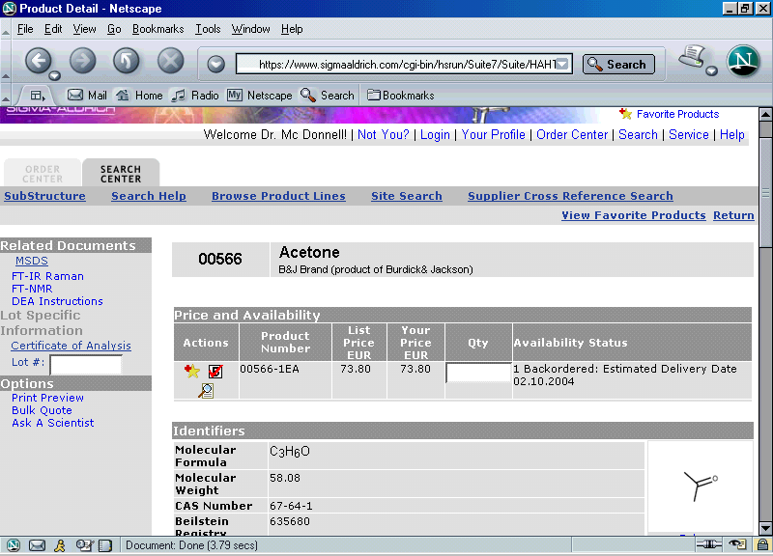

http://www.sigmaaldrich.com/Area_of_Interest/Europe_Home/Ireland.html

-YOUR WORKPLACE

Some useful websites;
Web of Science accessed through DIT library site
(see handouts beside desk Kevin Street library on how to use this resource)
www.chemsoc.org
www.chemweb.com
- free databases and forum; www.pharma.chemweb.com
www.chemind.org/CI/index.jsp (Chemistry and Industry)
www.amazon.com (book reviews and table of contents and sample pages)
http://www.rsc.org/lic/library.htm - RSC library and Information Centre – free to RSC members
http://www.chem.com/

SEARCH ENGINES
www.scirus.com www.google.com

FREE JOURNALS

The Alchemist (e-journal)

http://www.chemweb.com/alchemist
Pharmaceutical Technology Europe
http://www.ptemag.com/pharmtecheurope/

LCGC Europe http://www.lcgceurope.com/lcgceurope/

ASK STAFF TO ORDER RELEVANT BOOKS

